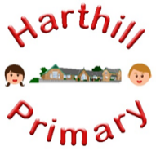

Curriculum Design at Harthill

Our curriculum enables children to:
- Understand concepts, themes and genres
- Acquire and apply knowledge and skill
- Develop vocabulary
So that they:
- develop a strong sense of belonging with a good understanding of the wider world.
- be inspired to raise their ambition.
- grow resilience as determined and independent individuals.
- show kindness, respect and tolerance.
MUSIC AT HARTHILL
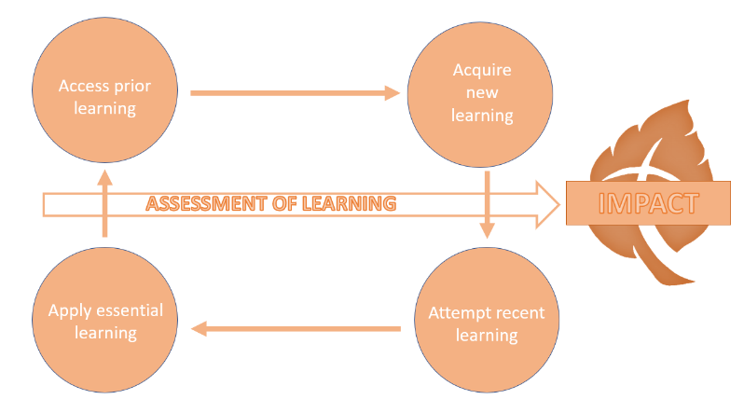
Intent: Through our music curriculum children will access, acquire, attempt and apply disciplinary (skill-based) and substantive (factual) knowledge to develop their musical abilities, following the Charanga curriculum. Charanga presents learning in a way that makes it fun and engaging for everyone, separating the key links into listening & responding, understanding & communicating and developing performance & skill. There is a song at the heart of every step of learning to engage and inspire pupils and provide a vehicle for their development of subject specific skills.
Our music curriculum has been designed with our children in mind to ensure it:
- Broadens pupil understanding and experiences of the world
- Meets the needs of all pupils and allows them to explore their creativity
- Gives them opportunity to explore individual interest and talent which they may not otherwise be able to do.
- Raises ambition through acquired knowledge and opportunities for application
- Promotes diversity through a variety of musicians and inspirational figures
- Challenges pupils and promotes resilience
Implementation:
Through our music curriculum children will:
-be taught new skills and learn new information about music and the different components that make up musical understanding and performance.
-learn about a variety of musical styles, instruments, songs and performances.
-develop their creativity, as well as the ability to thinking critically about music in all of its forms
-broaden awareness of historical and social significance of the practice, creation, and study of music
Impact:
The impact of our music curriculum is demonstrated in the following ways:
-what children say (pupil questioning, explanations, discussion contributions, verbal retrieval)
-what children do (performances, rehearsals and recordings).

