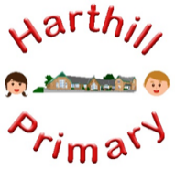

Curriculum Design at Harthill

Our curriculum enables children to:
- Understand concepts, themes and genres
- Acquire and apply knowledge and skill
- Develop vocabulary
So that they:
- develop a strong sense of belonging with a good understanding of the wider world.
- be inspired to raise their ambition.
- grow resilience as determined and independent individuals.
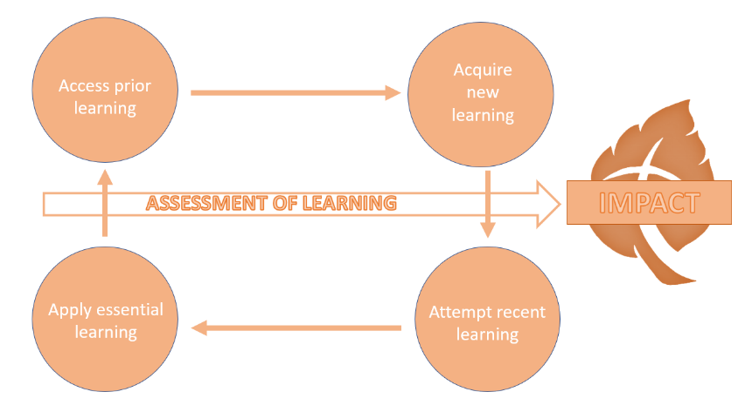
- show kindness, respect and tolerance.
HISTORY AT HARTHILL
Intent: Through our history curriculum children will access, acquire, attempt and apply substantive (factual) and disciplinary (skill-based) knowledge whilst building on their history vocabulary. They will learn about key periods, events and individuals in history, under the key concepts of power, conflict and achievement. They will also develop their understanding of how to interpret information and sources, chronology, continuity and change and how to present and communicate.
Our history curriculum has been designed with our children in mind to ensure it:
- Broadens pupil understanding and experiences of the world
- Meets the needs of all pupils and supports long term social mobility
- Raises ambition through acquired knowledge and opportunities for application
- Promotes diversity as well as British Values
- Challenges pupils and promotes resilience
Implementation:
Through our history curriculum children will:
-be taught new knowledge through the implementation of the History progression maps
-explore key concepts through the new knowledge
-make links and group knowledge to develop schemas
-build vocabulary as a result of direct teaching
- regularly retrieve learning to move knowledge from short term to long term memory
-practice the skills (disciplinary knowledge) of being a historian
Impact:
The impact of our history curriculum is demonstrated in the following ways:
-what children say (pupil questioning, explanations, discussion contributions, verbal retrieval)
-what children do (displays, floor books, history books, English books, mind-mapping for retrieval)

