SAFER RECRUITMENT
POLICY

September 2023

Date for Review: September 2024

Statement of intent
This policy is designed to assist with recruitment and selection at The James Montgomery Academy Trust (JMAT) and its schools. It outlines our recruitment procedure and is in-line with the DfE statutory guidance (Keeping Children Safe in Education 2023) on safeguarding.

Through this policy the JMAT aims to embed safer recruitment practices and procedures to ensure a more robust safeguarding culture at our school.

Roles and responsibilities:
The Local Governing Body (LGB) of the school is responsible for ensuring there are effective policies and procedures in place to ensure recruitment is in line with DfE statutory guidance and legal requirements.
The JMAT strives to ensure that staff recruitment is safe and fair, and the LGB continues to monitor this aspect of the school’s Safer Recruitment Policy alongside legal and statutory compliance.

The JMAT is required to ensure that checks on the right to work in the United Kingdom comply with the requirements of the Immigration, Asylum and Nationality Act 2006.

The Headteacher will assist the LGB in ensuring that staff recruitment is safe, fair and compliant. The Headteacher will also ensure appropriate checks have been carried out on staff, volunteers, contractors and agencies working within the school.
The Headteacher is also responsible for ensuring that appropriate supervision of employees/volunteers is organised, where necessary, and for promoting the safety and wellbeing of pupils generally, and throughout this process.
Inviting applications – advertisements
Vacancies will be advertised through external media, keeping in mind the JMAT Equal Opportunities Policy and the need to reach disadvantaged groups. A commitment to equal rights will be stated in advertisements.

Advertisements will include a job description, outline the person specifications potential candidates should display, and detail the closing date.

Recruitment will not be through ‘word of mouth’ and advertisement will aim to reach as broad an audience as possible (i.e. local advertising may not be appropriate).

The contact point for telephone or email enquiries will be clearly outlined and it is advisable that application forms are accessible both on the JMAT and from school, as well as being sent out to applicants.
Information for candidates
Information for candidates will include:
- Advertisement
- A comprehensive job description
- A comprehensive person specification
- Equal rights material
- A brief outline of the school, its values and aims
- An application form – to assist with fair comparisons between applicants. This will also include a section for references to be recorded, one of which should be the candidate’s most recent employer.

Identification of the recruitment panel

The recruitment panel will comprise of an ‘appointing officer’, responsible for the management of the entire recruitment process. Between two and four selectors is appropriate for most appointments.

At least one member of the panel including a governor should have successfully completed up to date training in safer recruitment.
Social media/online checks for job applicants
Keeping Children Safe in Education states that when schools are recruiting new staff they "should consider" performing online searches on candidates as part of their shortlisting process:

"As part of the shortlisting process, schools and colleges should consider carrying out an online search as part of their due diligence on the shortlisted candidates. This may help identify any incidents or issues that have happened, and are publicly available online, which the school or college might want to explore with the applicant at interview."

The JMAT and its schools reserve the right to carry out online checks for shortlisted candidates only, and will inform the candidate that a check is being made.

Shortlisting

All application forms (whether incomplete or completed) must be taken into account when shortlisting candidates for an interview.

Candidates who are shortlisted should meet all the essential aspects of the person specification requirements. This process will be as systematic as possible and all selectors will read through all applications, each creating their own shortlist. These will be collated and discussed between selectors before a final shortlist is decided on.
Interview invitations

Once a shortlist has been decided, the successful applicants will be contacted and a suitable interview time decided. Shortlisted candidates will also be sent an additional information form which includes a criminal record declaration.

References

Two referees, one of which must be the candidate’s most recent employer, will be contacted by the chair of the selection committee, ideally before candidates are interviewed.

Structured questionnaires are a useful method of questioning referees. Questions will include:
- General information about the candidate’s previous professional performance and suitability for the post.
- The candidate’s suitability to work with children and young people.
- Any disciplinary warnings, including time-expired warnings, relating to the safeguarding of children and young people.
- The applicant’s [sickness/attendance] record.
- The applicant’s disciplinary record.

If the candidate is applying for a teaching post and is not currently employed as a teacher, the school/local authority where they were most recently employed as a teacher should be contacted.

Records will be kept of these conversations, or written references requested, and any uncertainties or issues followed up with the referee verbally will be recorded.

Following reference checks, any concerns raised by referees will be put to the candidate at interview. Such conversations will also be recorded.
Digital footprints
Schools within the JMAT are committed to ensuring that safeguarding is a top priority. In light of this commitment, where appropriate, potential candidates’ social media or other online activity may be checked prior to interview and records made of any offensive or inappropriate material. This process may include a search for the candidate via but not limited to:
- Google
- Facebook
- LinkedIn

Selection process

During interviews candidates will be asked questions about their experience and ability to do the role which will include questions about safeguarding and questions relating to their application. Any concerns raised through contact with referees will be put to the candidate at this stage.

A job applicant can be asked relevant questions about disability and health in order to establish whether they have the physical and mental capacity for the specific role.

Barred list checks
KCSIE 2022 has added to the guidance explaining when separate barred list checks should be carried out.
These checks must only be carried out:
- for newly appointed staff who are engaging in regulated activity, pending the receipt of an Enhanced certificate with barred list information from the Disclosure and Barring Service (DBS)
- where a person has worked in a school or college in a role that brought them into regular contact with children and young people, and this role ended not more than three months prior to their new appointment
Employment checks and DBS checks (inc. “regulated activity”)
For the purpose of this policy, engaging in “regulated activity” involves any individual who:
- Will be responsible for teaching, training, instructing, caring for or supervising children at the school.
- Will carry out paid or unsupervised, unpaid work regularly at the school, and where that work provides an opportunity for contact with children.
- Engages in intimate or personal care or overnight activity, even if this happens only once.

Regulated activity is described as being “regular” if it is carried out by the same person and is conducted:
- On more than 3 days in a 30-day period.
- Overnight (between 2am-6am).

For all appointments in JMAT schools an enhanced DBS check with barred list information is required.
Current and prospective employees will not commence or continue their practice without a satisfactory DBS check and an appropriate risk assessment where required.
It is part of JMAT’s procedures that a prohibition from teaching check is carried out for all those employed to carry out teaching work* (teachers, HLTAs and TAs), in line with best practice as identified by recent JMAT inspections.

JMAT’s DBS policy covers the DBS process in further detail, including information regarding criminal convictions declarations for shortlisted candidates.

*The Teachers’ Disciplinary (England) Regulations 2012 define teaching work as: planned and preparing lessons and courses for pupils; delivering lessons to pupils; assessing the development, progress and attainment of pupils; and reporting on the development, progress and attainment of pupils.

General recruitment
The JMAT and its schools will take care to ensure that:

- A candidate’s identity is verified, preferably from a current photographic ID and proof of address. If none of these is available, the candidate is required to produce a birth certificate in conjunction with their national insurance number.
- Appropriate DBS checks are obtained for all candidates, including barred list information where the person is engaged in regulated activity.
- Where an individual is successful in their application, and begins work in a regulated activity before a DBS certificate is available, a separate barred list check will be obtained.
- Where applicants have subscribed to the DBS Update Service, and give permission for this to be accessed, this service will be used instead.
- Successful candidates for teaching positions are subject to a teaching prohibition order check, this will be done using the Employer Access Online service.
- The successful candidate has a right to work in the UK.
- Where a candidate has worked overseas, that appropriate checks are carried out per this policy.

Volunteers
Where a volunteer is recruited to engage in work which is not considered ‘regulated activity’, an enhanced DBS certificate will be obtained.

Volunteers recruited to take part in regulated activity must obtain an enhanced DBS certificate. Under no circumstances will a volunteer who has not provided a DBS certificate be left unsupervised or allowed to work in regulated activity.
Note: Where a volunteer is to be placed under supervision, they are not considered to be taking part in regulated activity and therefore it is illegal for the school to request a barred list check on the volunteer.
Supervision must:
- Be by a person who is in regulated activity.
- Be regular and day to day.
- Be “reasonable in all the circumstances to ensure the protection of children”.

KCSIE January 2021 update (post-Brexit) - Individuals who have lived and/or worked outside the UK

From 1 January 2021 the TRA Teacher Services will no longer maintain a list of those teachers sanctioned in EEA member states. If applicable, schools must make further checks on a teacher’s past conduct which could include the following:
- Criminal records checks for overseas applicants
- If the applicant has applied for a teaching position, a letter of professional standing from the professional regulating body of the country where the applicant has worked.

No exceptions will be made for candidates who have lived outside of the UK, all mandatory checks outlined in this policy will be carried out, along with additional checks where necessary.

The DfE guidance on the employment of overseas-trained teachers will be consulted should an overseas candidate apply for a teaching position.

Applicants who have lived/travelled abroad for more than 3 months will need to obtain a criminal record check from the relevant country. The applicant will not be permitted to commence work until the overseas information has been received and is considered satisfactory by school.

Agency and third-party staff
In the case of any employee working at JMAT and its schools sourced from an agency or third-party organisation, confirmation must be obtained from the organisation, in writing, that all necessary DBS checks have been completed. Agency and third-party employees must produce their DBS certificate, and a record of the number will be retained.

Confirmation must also be obtained that the individual who presents for work is the same person on whom all checks have been completed. A copy of photographic identification is generally appropriate.

Trainee/student teachers
At JMAT we will ensure that enhanced DBS certificates and barred list checks are obtained on all applicants for initial teacher training.

Where trainee teachers are fee-funded it is the responsibility of the initial teacher training provider to carry out the necessary checks.

Decision making

At the James Montgomery Academy Trust we strive to employ the most suitable candidate for the post, only those candidates who meet the essential criteria will be interviewed and all essential criteria must be met before any offers of employment are made.

In line with our safeguarding obligations, we will carefully consider all information about past disciplinary action or allegations. This includes information obtained from the Employer Access Online checks.
Single central record
In line with ‘Keeping Children Safe in Education 2023’, School Staffing Regulations and Childcare Disqualification Regulations 2006, JMAT and its schools will maintain and regularly update the single central record. All new employees will be added to the record, which will include:
- All staff (including supply, contract and agency staff) who work at the school.
- All others who work in regular contact with children in the school or college, including volunteers.
- Members of the local governing body
For each individual, the single central record will outline whether or not the following checks have been carried out/certificates obtained, along with the date of the check:
- An identity check
- A barred list check
- An enhanced DBS check
- A prohibition from teaching check
- Further checks on people living or working outside the UK
- A check of professional qualifications
- A check to establish the person’s right to work in the UK
- A section 128 direction check for management positions only

Monitoring, Evaluation and Policy review

The policy will be promoted and implemented throughout the JMAT schools.

This policy will be assessed for its implementation and effectiveness annually by the Trust Safeguarding Lead.

The scheduled review date for this policy is September 2024.

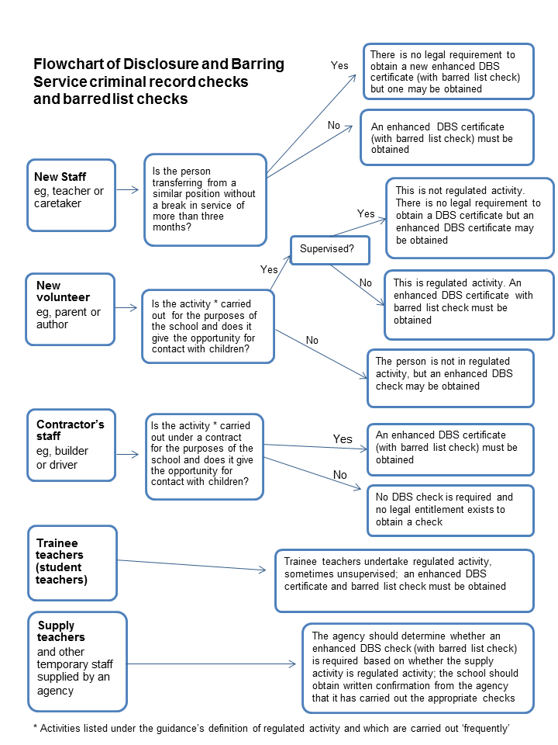
Annex 1: Flowchart of Disclosure and Barring Service criminal record checks and barred list

