Substantive knowledge  Our curriculum supports pupils to:  - Understand concepts, themes and genres  - Acquire and apply knowledge and skill  - Develop vocabulary |  |  |  | Disciplinary knowledge  Our curriculum supports pupils to:  - Ask questions  - Investigation to find new information  - Present, organise and communicate
KS2 TIER 1
Key concepts  Key vocabulary | Animals inc. humans | Plants | Forces and magnets |  | Sound | Rocks and soils
Tier 1 | Accessing Prior Learning?  What is a healthy diet and why is it important? | Accessing Prior Learning:  What do plants need to be healthy? | Accessing Prior Learning:  What would a fridge magnet ‘stick’ to? |  | Accessing Prior Learning:  What are the different ways we can make sounds? | Accessing Prior Learning:  How do we know about dinosaurs when they died a long time ago?
 | Acquiring + Attempting New Learning:  - Identify that animals, including humans, need the right types and amount of nutrition, and that they cannot make their own food; they get nutrition from what they eat  - Identify that humans and some other animals have skeletons and muscles for support, protection and movement  - Describe the simple functions of the basic parts of the digestive system in humans  - Identify the different types of teeth in humans and their simple functions  - Construct and interpret a variety of food chains, identifying producers, predators and prey | Acquiring + Attempting New Learning:  - identify and describe the functions of different parts of flowering plants: roots, stem/trunk, leaves and flowers  - explore the requirements of plants for life and growth (air, light, water, nutrients from soil, and room to grow) and how they vary from plant to plant  - investigate the way in which water is transported within plants  - explore the part that flowers play in the life cycle of flowering plants, including pollination, seed formation and seed dispersal | Acquiring + Attempting New Learning:  - compare how things move on different surfaces  - notice that some forces need contact between two objects, but magnetic forces can act at a distance  - observe how magnets attract or repel each other and attract some materials and not others  - describe magnets as having two poles  - compare and group together a variety of everyday materials on the basis of whether they are attracted to a magnet, and identify some magnetic materials  - predict whether two magnets will attract or repel each other, depending on which poles are facing |  | Acquiring + Attempting New Learning:  - identify how sounds are made, associating some of them with something vibrating  - recognise that vibrations from sounds travel through a medium to the ear  - find patterns between the pitch of a sound and features of the object that produced it  - recognise that sounds get fainter as the distance from the sound source increases  - find patterns between the volume of a sound and the strength of the vibrations that produced it | Acquiring + Attempting New Learning:  - compare and group together different kinds of rocks on the basis of their appearance and simple physical properties  - describe in simple terms how fossils are formed when things that have lived are trapped within rock  - recognise that soils are made from rocks and organic matter
Additional vocabulary (included in the non-statutory guidance) | Diet  Food groups  Mouth  Tongue  Teeth  Oesophagus  Stomach  Small intestine  Large intestine  Herbivores  Carnivores | Structure  Nutrition  Reproduction | Strength |  | Insulation | Grains  Crystals  Sedimentary rocks
Cycle A  Scientist and career study | 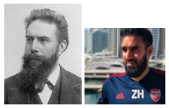Willhelm Röntgen  (Invented the X-Ray)  Zubair Haleem  (Academy physio at Arsenal)  Physiologist (a scientist who  studies how plants and animals function)  Dietician (develops nutrition  advice to improve people’s  diets) | 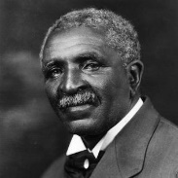 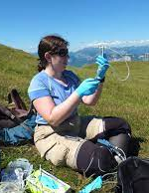George Washington  Carver  (Agricultural Scientist who  encouraged the planting of  different crops to prevent  soil degradation)  Dr Kelsey Byers  (Biologist who studies  flower smells and how they  attract insects)  Crop physiologists (study all forms of plant life in the laboratory)  Propagation scientist (study the best ways to create new plants from old by collecting seeds, taking cuttings or through micropropagation) | 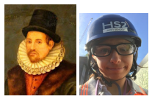William Gilbert  (Magnetism and electricity)  Jyoti Sehdev  (Senior civil engineer)  Geographic Explorer)  Architect (designs buildings)  Seismologist (studies  earthquakes) |  | 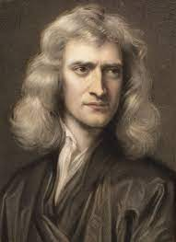Evelyn Glennie  (Deaf percussionist)  Isaac Newton  (Mathematician & Physicist  who measured the speed of  sound)  Audiologist (studies sound and its properties) | 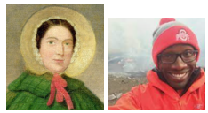  Mary Anning  (Fossilist)  Christopher Jackson  (geologist)  Geologist (studies the Earth and what it is made of, including rocks)  Volcanologist (studies  volcanoes)
Cycle B  Scientist and career study | 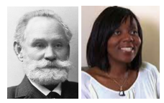Ivan Pavlov  (Physiologist)  Charlotte Armah  (nutritional biochemist - looking at the effect of diet on human health)  Orthodontist (a doctor who looks after people’s teeth and gums)  Nutritionist (studies nutrition in food and how it affects our bodies) | 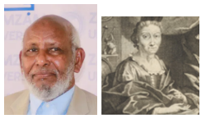Ahmed Mumin Warfa  (Somali Botanist)  Maria Sibylla Merian (1647-1717)  (Documented the relationship  between plants and insects)  Horticulturist (an expert in  garden cultivation and  management)  Irrigation engineer (creates and develops water systems) | 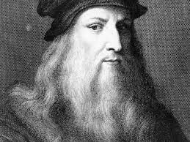 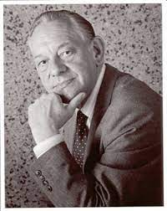Leonardo Da Vinci  (First person to plan and  carry out tests on friction)  Eric Laithwaite  (Electrical Engineer who  developed the technology  behind the Maglev train)  Mechanic (using electromagnetism in cars)  Robotic engineer (utilising magnetic forces withing robots) |  | 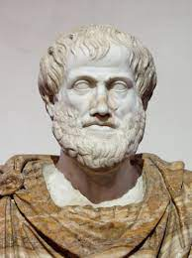 Aristotle  (Philosopher who  developed the concept that  sound travels through air  due to the movement of air  particles)  Karrie Keyes  (Audio engineer)  Sound engineer (deals with sound for broadcasts or musical performances) | 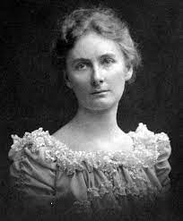 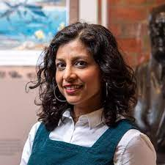Florence Bascom  (Geologist who studied the  origin and formation of  mountains)  Anjana Khatwa  (Geologist who collects  rocks and fossils from the  beach and studies them)  Volcanologist (studies  volcanoes)
 | Applying Essential Learning:  Name a part of the body and what it does. | Applying Essential Learning:  Why do plants have flowers? | Applying Essential Learning:  How can we move magnets? |  | Applying Essential Learning:  How can we make different sounds? | Applying Essential Learning:  What are rocks and soils like?
Impact evidence:
- Pupil knowledge
- Class floor books
- Displays
- English books

