Active Learn Programme Structure
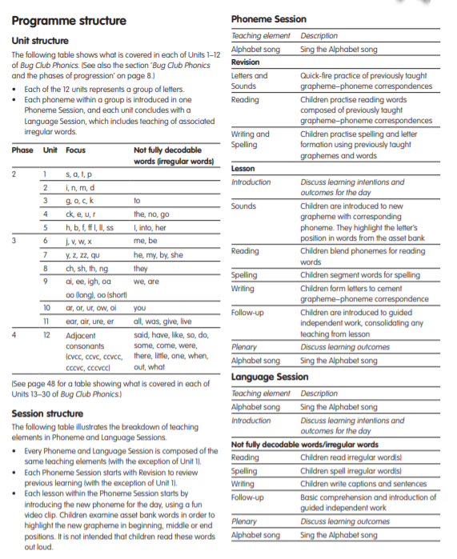

Additional notes on phonics teaching
- Teach plural ‘s’ at the same time as teaching ‘s’
- Teach ‘th’ as in ‘this’ at the same time as ‘th’ in ‘thing’- slightly different pronunciation
- If there are double letters- treat it as one eg ‘pp’ in hopping or ‘nn’ in running. Make this explicit to children.
- Introduce that where ‘ (apostrophes) are used, they do not change how a word is blended to read but they will learn about WHY they’re used later on in the phonics programme
- We have a collection of books (Introduction to Phase 4)- these include previously taught sounds for blending, including adjacent consonants, but do not include phase 4 tricky words. These are for additional practice for children who are consolidating phase 3.
- After Phase 3 unit 8 ‘ing’ is included in some of the reading books as it can be decoded however it is not taught as a suffix until phase 6 (Y2).

