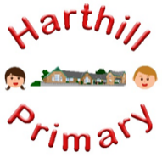

Curriculum Design at Harthill

Our curriculum enables children to:
- Understand concepts, themes and genres
- Acquire and apply knowledge and skill
- Develop vocabulary
So that they:
- develop a strong sense of belonging with a good understanding of the wider world.
- be inspired to raise their ambition.
- grow resilience as determined and independent individuals.
- show kindness, respect and tolerance.
SCIENCE AT HARTHILL
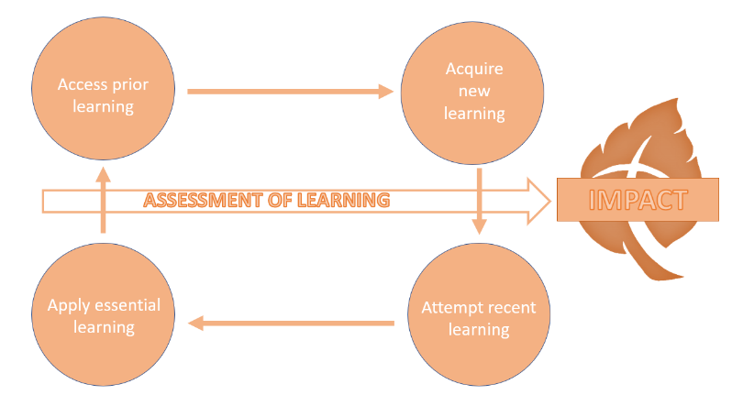
Intent: Through our science curriculum children will access, acquire, attempt and apply substantive (factual) and disciplinary (skill-based) knowledge whilst building on their scientific vocabulary. They will develop scientific knowledge and conceptual understanding through the specific disciplines of biology, chemistry and physics. They will develop skills in different types of scientific enquiries that help them to ask and answer scientific questions about the world around them. They will also learn about scientists (both historic and current), different science-focused careers and will be equipped with the scientific knowledge required to understand the uses and implications of science, today and for the future.
Our science curriculum has been designed with our children in mind to ensure it:
- Broadens pupil understanding and experiences of the world
- Promotes curiosity about how the world works
- Meets the needs of all pupils and supports long term social mobility
- Raises ambition through acquired knowledge and opportunities for application and awareness of the significance of scientific development and potential future careers
- Challenges pupils and promotes resilience
- Prepare pupils for building on their learning about science at the next phase of their education

Implementation:
Through our science curriculum children will:
-be taught new knowledge through the implementation of the science progression maps
-explore key concepts through the new knowledge
-make links and group knowledge to develop schemas
-build vocabulary as a result of direct teaching
- regularly retrieve learning to move knowledge from short term to long term memory
-practice the skills (disciplinary knowledge) of being a scientist
Impact:
The impact of our science curriculum is demonstrated in the following ways:
-what children say (pupil questioning, explanations, discussion contributions, verbal retrieval)
-what children do (displays, floor books, science books, English books, mind-mapping for retrieval)

