Substantive knowledge  Our curriculum supports pupils to:  - Understand concepts, themes and genres  - Acquire and apply knowledge and skill  - Develop vocabulary |  |  |  | Disciplinary knowledge  Our curriculum supports pupils to:  - Ask questions  - Investigation to find new information  - Present, organise and communicate
KS2 Tier 2
Key concepts  Key vocabulary | Living things and their habitats |  | States of matter  Properties and changes of materials |  | Electricity | Earth and Space
TIER 2 | Accessing Prior Learning?  Why do different animals live in different places? |  | Accessing Prior Learning:  Can we change materials? |  | Accessing Prior Learning:  Which products need electricity to make them work? | Accessing Prior Learning:  What do you know about light and dark?
 | Acquiring + Attempting New Learning:  - Recognise that living things can be grouped in a variety of ways  - Explore and use classification keys to help group, identify and name a variety of living things in their local and wider environment  - Recognise that environments can change and that this can sometimes pose dangers to living things |  | Acquiring + Attempting New Learning:  - compare and group materials together, according to whether they are solids, liquids or gases  - observe that some materials change state when they are heated or cooled, and measure or research the temperature at which this happens in degrees Celsius (°C)  - identify the part played by evaporation and condensation in the water cycle and associate the rate of evaporation with temperature  compare and group together everyday materials on the basis of their properties, including their hardness, solubility, transparency, conductivity (electrical and thermal), and response to magnets  - know that some materials will dissolve in liquid to form a solution, and describe how to recover a substance from a solution  - use knowledge of solids, liquids and gases to decide how mixtures might be separated, including through filtering, sieving and evaporating  - give reasons, based on evidence from comparative and fair tests, for the particular uses of everyday materials, including metals, wood and plastic  - demonstrate that dissolving, mixing and changes of state are reversible changes  - explain that some changes result in the formation of new materials, and that this kind of change is not usually reversible, including changes associated with burning and the action of acid on bicarbonate of soda |  | Acquiring + Attempting New Learning:  - identify common appliances that run on electricity  - construct a simple series electrical circuit, identifying and naming its basic parts, including cells, wires, bulbs, switches and buzzers  - identify whether or not a lamp will light in a simple series circuit, based on whether or not the lamp is part of a complete loop with a battery  - recognise that a switch opens and closes a circuit and associate this with whether or not a lamp lights in a simple series circuit  - recognise some common conductors and insulators, and associate metals with being good conductors  - associate the brightness of a lamp or the volume of a buzzer with the number and voltage of cells used in the circuit  - compare and give reasons for variations in how components function, including the brightness of bulbs, the loudness of buzzers and the on/off position of switches  - use recognised symbols when representing a simple circuit in a diagram | Acquiring + Attempting New Learning:  - describe the movement of the Earth, and other planets, relative to the Sun in the solar system  - describe the movement of the Moon relative to the Earth  - describe the Sun, Earth and Moon as approximately spherical bodies  - use the idea of the Earth’s rotation to explain day and night and the apparent movement of the sun across the sky
Additional vocabulary (included in the non-statutory guidance)  *appear in previous year groups | Plants*  Animals *  Habitat *  Flowering plants *  Non-flowering plants  Vertebrates  Fish *  Amphibians *  Reptiles *  Birds *  Deforestation | Mammals *  Invertebrates  Snails and slugs  Worms  Spiders  Insects  Human impact  Positive  Negative  Population  Development  Litter | Oxygen condensing  Iron melting  rusting  melting  Polymers  Super sticky materials  Super thin materials |  | Components  Motors  Safety  Simple devices  systematically  Safety  Changing | Mercury  Venus  Earth  Mars  Jupiter  Saturn  Uranus  Neptune | moons  Celestial body  orbit  Safety  Astronomical clocks  Sundials  Calibration
Cycle A  Scientist and career study | Prem Singh Gill  (Polar scientist)  Gladys West  (Mathematician/GPS)  Conservationist (works for the protection and preservation of living things and the environment) |  | 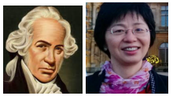  Ivan Pavlov  (Physiologist)  Charlotte Armah  (nutritional biochemist - looking at the effect of diet on human health)  Orthodontist (a doctor who looks after people’s teeth and gums)  Nutritionist (studies nutrition in food and how it affects our bodies) |  | 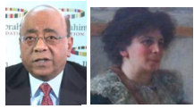 Mo Ibrahim  (Pioneer in the mobile phone  industry)  Hertha Ayrton  (Engineer, physicist,  mathematician and inventor)  Physicist (studies physics) | 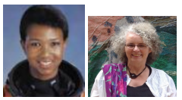Mai Jemison  (Astronaut)  Dr Helen Mason  (Solar scientist)  Astronaut (travels to space to  carry out research)  Astronautical engineer (develops spacecraft)
Cycle B  Scientist and career study | 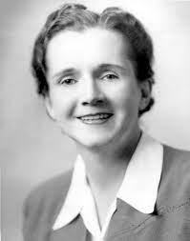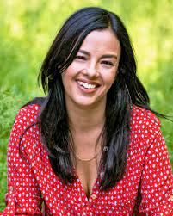  Rachel Carson  (Aquatic Biologist who wrote  about environmental  pollution)  Liz Bonnin  (TV Presenter & Wildlife  Conservationist)  Ecologist (studies interactions  between living things and their environments) |  | Becky Schroeder  (Inventor of the glow sheet)  Dr Nira Chamberlain  (polymath/mathematician who studies applied mathematics in science)  Chemical engineer (solves  problems involving chemicals)  Biochemist (investigates chemical processes that take place inside living things) |  | 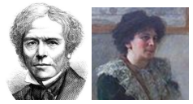 Michael Faraday  (Physicist)  Hertha Ayrton  (Electrical engineer and sufragette)  Electrical engineer (works with equipment that uses electricity) | 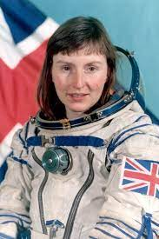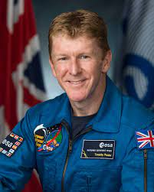  Helen Sharman (astronaut)  Tim Peake (astronaut)  Astrophysicist (studies the  physics of space and objects in space)
 | Applying Essential Learning:  Are living things in danger? |  | Applying Essential Learning:  How can we separate a mixture of water, iron filings, salt and sand? |  | Applying Essential Learning:  Can we vary the effects of electricity? | Applying Essential Learning:  Sun, Earth & Moon: What is moving and how do we know?
Impact evidence:
- Pupil knowledge
- Class floor books
- Displays
- English books

