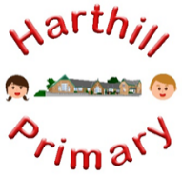

Curriculum Design at Harthill

Our curriculum enables children to:
- Understand concepts, themes and genres
- Acquire and apply knowledge and skill
- Develop vocabulary
So that they:
- develop a strong sense of belonging with a good understanding of the wider world.
- be inspired to raise their ambition.
- grow resilience as determined and independent individuals.
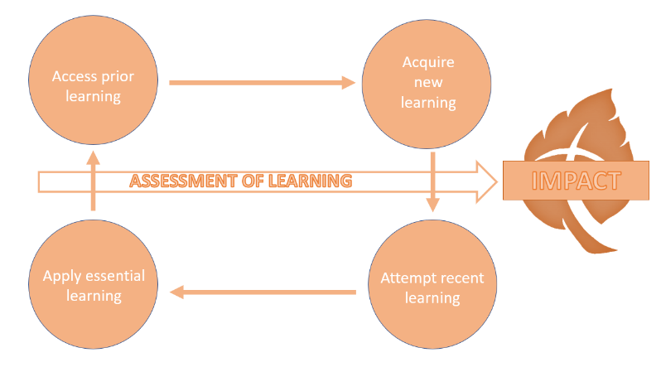
- show kindness, respect and tolerance.
GEOGRAPHY AT HARTHILL
Intent: Through our geography curriculum children will access, acquire, attempt and apply substantive (factual) and disciplinary (skill-based) knowledge whilst building on their geographical vocabulary. They will learn about the environment, the natural world, modified landscapes and the social environment under the key concepts of location and place, biomes and natural processes and ecology and humans. They will also learn how to develop their methods and approaches of geographical interpretations and enquiry, identify cause, consequence and continuity as well as more practical techniques such as using maps.
Our Geography curriculum has been designed with our children in mind to ensure it:
- Broadens pupil understanding and experiences of the world
- Promotes diversity through their knowledge of the world
- Meets the needs of all pupils and supports long term social mobility
- Raises ambition through acquired knowledge and opportunities for application
- Challenges pupils and promotes resilience
- Enables children to find out and make sense of the world by working like a ‘geographer’
Implementation:
Through our geography curriculum children will:
-be taught new knowledge through the implementation of the geography progression maps
-explore key concepts through the new knowledge
-make links and group knowledge to develop schemas
-build vocabulary as a result of direct teaching
-developing a broader understanding of the United Kingdom, and world at large (continents, oceans, countries)
- regularly retrieve learning to move knowledge from short term to long term memory
-practice the skills (disciplinary knowledge) of being a geographer

Impact:
The impact of our Geography curriculum is demonstrated in the following ways:
-what children say (pupil questioning, explanations, discussion contributions, verbal retrieval)
-what children do (displays, floor books, Geography books, English books, mind-mapping for retrieval)

