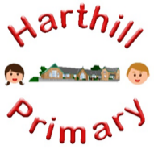

Curriculum Design at Harthill

Our curriculum enables children to:
- Understand concepts, themes and genres
- Acquire and apply knowledge and skill
- Develop vocabulary
So that they:
- develop a strong sense of belonging with a good understanding of the wider world.
- be inspired to raise their ambition.
- grow resilience as determined and independent individuals.
- show kindness, respect and tolerance.
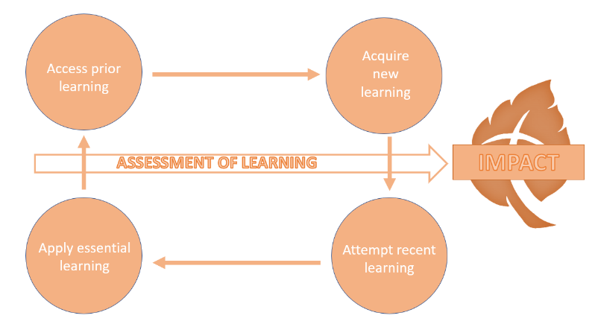
PHYSICAL EDUCATION AT HARTHILL
Intent: Through our PE curriculum children will access, acquire, attempt and apply disciplinary (skill-based) knowledge whilst building on their vocabulary. They will master basic movements, learn the rules to specific sports and associated vocabulary as well as mastering the skills to work together as a team. In KS2, children learn through Sports Education, where they develop the skills of leadership, coaching, referring and managing resources needed to succeed as a team.
Our PE curriculum has been designed with our children in mind to ensure it:
- Provides opportunities for pupils to become physically confident in a way which supports their health and fitness
- Encourages children to find a physical activity they enjoy for future mental and physical health benefits
- Broadens pupil understanding and experiences of the world
- Meets the needs of all pupils and ensures all children can access the curriculum, including those with disabilities
- Raises ambition through acquired disciplinary knowledge and opportunities for application
- Promotes diversity as well as British Values
- Challenges pupils and promotes resilience

Implementation:
Through our PE curriculum children will:
-be taught new knowledge through the implementation of the PE progression maps
-explore key concepts through the new knowledge
-make links and group disciplinary knowledge to develop schemas with reference to physical activity and sport
-build vocabulary as a result of direct teaching
- regularly retrieve learning to develop ability
-practice the skills (disciplinary knowledge) of being a sportsperson

Impact:
The impact of our PE curriculum is demonstrated in the following ways:
-what children say (pupil questioning, explanations, discussion contributions, verbal retrieval)
-what children do (skill demonstration, applying rules of a sport and teamwork)

