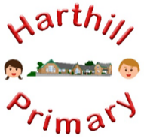

Curriculum Design at Harthill

Our curriculum enables children to:
- Understand concepts, themes and genres
- Acquire and apply knowledge and skill
- Develop vocabulary
So that they:
- develop a strong sense of belonging with a good understanding of the wider world.
- be inspired to raise their ambition.
- grow resilience as determined and independent individuals.
- show kindness, respect and tolerance.
PSHE AT HARTHILL
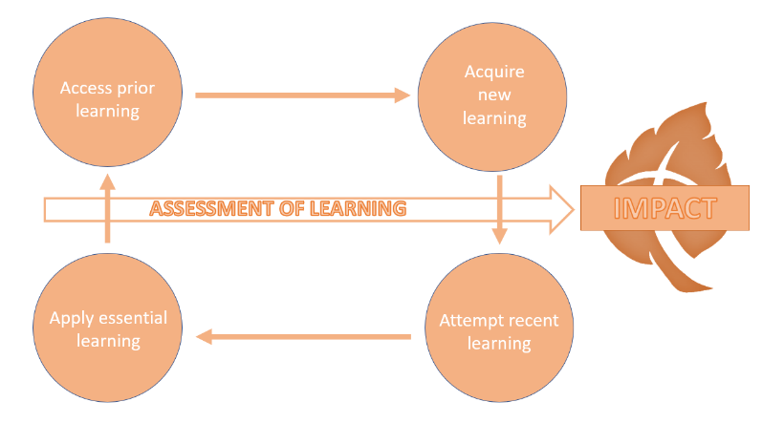
Intent: Through our PSHE curriculum children will access, acquire attempt and apply substantive (factual) and disciplinary (skill-based) knowledge whilst building on their PSHE vocabulary. They will follow the Jigsaw programme of study, working their way through six ‘puzzles’ including: Being Me in my World, Celebrating Difference, Dreams and Goals, Healthy Me, Relationships and Changing Me. At the start of each ‘puzzle’ the children will access their prior learning in this area before moving on to acquire new subject knowledge and skills relevant to their age group. As part of the Relationships and Healthy Me puzzle, pupils will be delivered the RSE curriculum which will include learning about healthy relationships.
Our PSHE curriculum has been designed with our children in mind to ensure it:
- Broadens pupil understanding and experiences of the world
- Meets the needs of all pupils
- Raises self and societal awareness and their understanding of themselves and others
- Promotes diversity, tolerance and acceptance as well as British Values
- Challenges pupils and promotes kindness and resilience in challenging situations.
Implementation:
Through our PSHE curriculum children will:
-be taught new knowledge through the implementation of the Jigsaw programme of study.
-explore key concepts through the new knowledge
-make links and group knowledge to develop schemas
-build vocabulary as a result of direct teaching
- regularly retrieve learning to move knowledge from short term to long term memory
-practice the skills acquired daily in social situations
Impact:
The impact of our PSHE curriculum is demonstrated in the following ways:
-what children say (pupil questioning, explanations, discussion contributions, verbal retrieval)
-what children do (displays, floor books, mind-mapping for retrieval)
-how the children interact both with each other and with the adults in our community

