Substantive knowledge  Our curriculum supports pupils to:  - Understand concepts, themes and genres  - Acquire and apply knowledge and skill  - Develop vocabulary |  |  |  |  | Disciplinary knowledge  Our curriculum supports pupils to:  - Ask questions  - Investigation to find new information  - Present, organise and communicate
KS2 Tier 3
Key concepts  Key vocabulary | Animals inc. humans | Living things and their habitats |  | Light |  | Evolution and inheritance | Forces
TIER 3 | Accessing Prior Learning?  What do our bodies do with the food we eat? | Accessing Prior Learning:  How are animals grouped? |  | Accessing Prior Learning:  When do shadows appear? |  | Accessing Prior Learning:  Do all plants and animals reproduce in the same way? | Accessing Prior Learning:  How can we move magnets?
 | Acquiring + Attempting New Learning:  - identify and name the main parts of the human circulatory system, and describe the functions of the heart, blood vessels and blood  - recognise the impact of diet, exercise, drugs and lifestyle on the way their bodies function  - describe the ways in which nutrients and water are transported within animals, including humans | Acquiring + Attempting New Learning:  - describe the differences in the life cycles of a mammal, an amphibian, an insect and a bird  - describe the life process of reproduction in some plants and animals  - describe how living things are classified into broad groups according to common observable characteristics and based on similarities and differences, including micro-organisms, plants and animals  - give reasons for classifying plants and animals based on specific characteristics. |  | Acquiring + Attempting New Learning:  - recognise that they need light in order to see things and that dark is the absence of light  - notice that light is reflected from surfaces  - recognise that light from the sun can be dangerous and that there are ways to protect their eyes  - find patterns in the way that the size of shadows change  - recognise that shadows are formed when the light from a light source is blocked by a solid object  - recognise that light appears to travel in straight lines  - use the idea that light travels in straight lines to explain that objects are seen because they give out or reflect light into the eye  - explain that we see things because light travels from light sources to our eyes or from light sources to objects and then to our eyes  - use the idea that light travels in straight lines to explain why shadows have the same shape as the objects that cast them |  | Acquiring + Attempting New Learning:  - recognise that living things have changed over time and that fossils provide information about living things that inhabited the Earth millions of years ago  - recognise that living things produce offspring of the same kind, but normally offspring vary and are not identical to their parents  - identify how animals and plants are adapted to suit their environment in different ways and that adaptation may lead to evolution | Acquiring + Attempting New Learning:  - explain that unsupported objects fall towards the Earth because of the force of gravity acting between the Earth and the falling object  - identify the effects of air resistance, water resistance and friction, that act between moving surfaces  - recognise that some mechanisms, including levers, pulleys and gears, allow a smaller force to have a greater effect
Additional vocabulary (included in the non-statutory guidance)  *appear in previous year groups | Skeletal system *  Muscular system *  Digestive system *  Healthy*  Substances  Harmful | Local environment *  Naturalists  Animal behaviourists  Reproduction *  Sexual reproduction  Asexual reproduction  rainforest  Ocean  Desert areas  Prehistoric times  Parent plant  Seeds *  Stem *  Root cuttings  Tubers  Bulbs * | Classification system  Invertebrates *  Insects *  Spiders *  Snails *  Worms *  Vertebrates *  Fish *  Amphibians *  Reptiles *  Mammals *  Birds *  Keys *  Unfamiliar environment  Habitats * | Mirror  Reflective  Reflection  Periscope  Shadow puppets  Coloured filters  Phenomena |  | Characteristics  Breeds  Variation  More able to survive  Less able to survive  Palaeontologists  Advantages  Disadvantages
Cycle A | 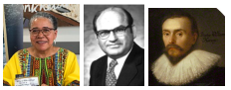  Elizabeth Anionwu  (Sickle cell and thalassemia specialist)  Barouh Berkovits  (invented the pacemaker and defibrillator)  Cardiologist (a doctor specialising in the heart and circulatory system) | 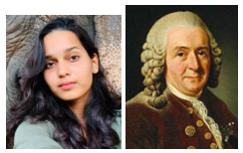  Malaika Vaz  (National Geographic explorer)  Carl Linneus  (botanist and zoologist)  Farmer (grows crops and raises  animals for food)  Oceanographer (studies the  physical and biological aspects  of the ocean) |  | 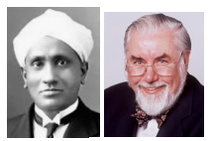 CV Raman  (Physicist)  Professor Colin Webb  (Professor of Laser Physics)  Architect (designs buildings) Ophthalmologist (a doctor specialising in vision and eye health) |  | 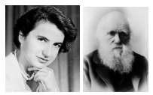  Rosalind Franklin  (Discovered the structure of DNA)  Charles Darwin  (Naturalist, developed the theory of evolution)  Archeologist (studies history using artefacts)  Geneticist (studies genes) | 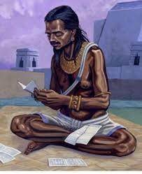 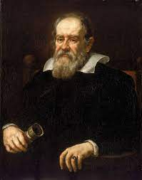Brahmagupta  (Mathematician &  Astronomer who was the  first scientist to talk about  gravity)  Galileo Galilei  (tested theories about gravity and the Solar System)
Cycle B | 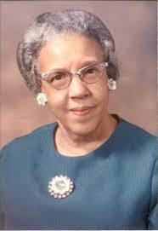  William Harvey  (Discovered how blood moves through the body)  Ruth Ella Moore  (Bacteriologist who  researched immunology,  blood groups and  tuberculosis)  Haematologist (studies blood and its diseases) | 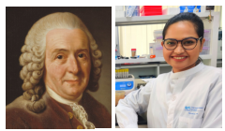  Carl Linneus  (Naturalist and botanist)  Nazifa Tabassum  (Microbiologist and Science  Communicator)  Microbiologist (studies tiny living things)  Plant geneticist (studies  genetics in plants - many work on developing crops to be more robust or provide more nutrition) |  | 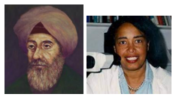Ibn al-Haytham  (Mathematician and astronomer)  Patricia Bath  (Ophthalmologist and inventor)  Astronomer (studies space)  Optician (a doctor specialising in vision and eye health) |  | 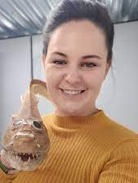 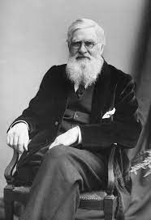Emma Dunne  (Palaeobiologist who  investigates how ancient  climate change affected the  evolution of different  species)  Alfred Wallace  (Natural Historian who  developed the theory of  evolution by natural  selection)  Palaeontologist (studies fossils) | 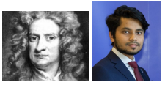 Isaac Newton  (Discovered gravity)  Rafsan Chowdhury  (Mechanical Engineer)  Aeronautical engineer (designs, develops, manufactures and maintains aircraft)  Builder (builds structures)  Mechanical engineer (designs, analysis and manufactures mechanical systems)
 | Applying Essential Learning:  How do our choices affect how our bodies work? Why does my heart beat? | Applying Essential Learning:  In what ways can we sort living things? |  | Applying Essential Learning:  Describe how light helps us to see. What is a shadow? |  | Applying Essential Learning:  What is evolution? | Applying Essential Learning:  How and why do objects move?
Impact evidence:
- Pupil knowledge
- Class floor books
- Displays
- English books

