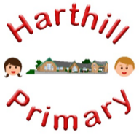

Curriculum Design at Harthill

Our curriculum enables children to:
- Understand concepts, themes and genres
- Acquire and apply knowledge and skill
- Develop vocabulary
So that they:
- develop a strong sense of belonging with a good understanding of the wider world.
- be inspired to raise their ambition.
- grow resilience as determined and independent individuals.
- show kindness, respect and tolerance.
MFL AT HARTHILL
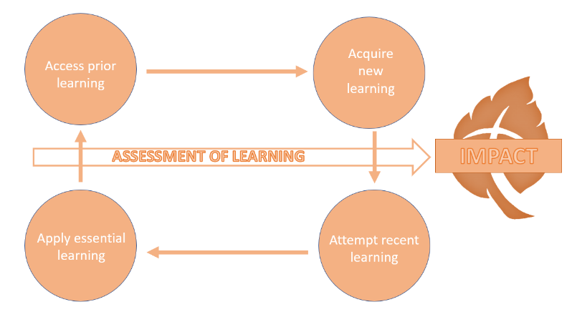
Intent: Through our Modern Foreign Language curriculum, children in KS2 will access, acquire, attempt and apply substantive (factual) and disciplinary (skill-based) knowledge whilst building on their Spanish speaking, listening, reading and writing skills. Following the Twinkl scheme, we aim to inspire pupils to develop a love of languages and to expand their horizons to other countries, cultures and people. We intend to help children grow into curious, confident and reflective language learners and to provide them with a foundation that will equip them for further language studies.
Our Spanish curriculum has been designed with our children in mind to ensure it:
- Broadens pupil understanding and experiences of the world
- Meets the needs of all pupils and supports long term social mobility
- Raises ambition through acquired knowledge and opportunities for application
- Promotes diversity as well as British Values
- Challenges pupils and promotes resilience
- Prepare pupils for building on their MFL learning at the next phase of their education

Implementation:
Through our MFL curriculum children will:
-build on prior knowledge and begin to develop a specific skill
-be offered an insight into the culture of Spanish-speaking countries and communities
-build vocabulary and grammatical structures as a result of direct teaching
- regularly retrieve learning to move knowledge from short term to long term memory
-practice speaking Spanish

Impact:
The impact of our MFL curriculum is demonstrated in the following ways:
-an increased profile of languages across school
-what children say (pupil questioning, explanations, discussion contributions, verbal retrieval)
-what children do (displays, mind-mapping for retrieval)

