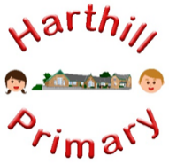

Curriculum Design at Harthill

Our curriculum enables children to:
- Understand concepts, themes and genres
- Acquire and apply knowledge and skill
- Develop vocabulary
So that they:
- develop a strong sense of belonging with a good understanding of the wider world.
- be inspired to raise their ambition.
- grow resilience as determined and independent individuals.
- show kindness, respect and tolerance.
ART AT HARTHILL
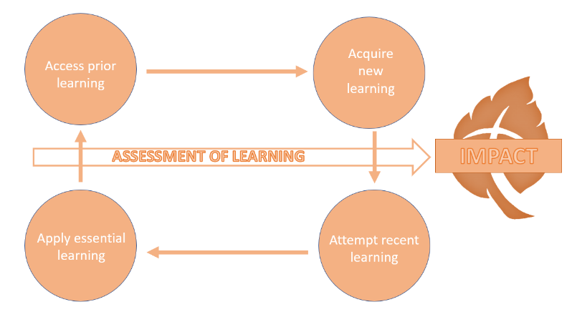
Intent: Through our Art curriculum children will access, acquire, attempt and apply disciplinary (skill-based) and substantive (factual) knowledge to develop their artistic abilities. They will be taught specific skills to apply their drawing, painting and sculpting creatively, learning about a variety of styles and focused artists, chosen in line with the teaching content for each tier. They will learn about local and national artists and their work, past and present. They will be taught to draft, refine and communicate work in different ways.
Our art curriculum has been designed with our children in mind to ensure it:
- Broadens pupil understanding and experiences of the world through diverse styles and artists
- Meets the needs of all pupils and allows them to explore their creativity
- Gives them opportunity to explore individual interest and talent which they may not otherwise be able to do.
- Raises ambition through acquired knowledge and opportunities for application
- Promotes diversity through a variety of artists and subjects
- Challenges pupils and promotes resilience
- Allows pupils to access a wide variety of subjects through creative media
Implementation:
Through our art curriculum children will:
-be taught new skills and learn new information about art and artistic media
-learn about a variety of techniques, materials, and artistic movements
-develop their creativity, as well as the ability to thinking critically about art in all of its forms
-broaden awareness of historical and social significance of the practice, creation, and study of art
Impact:
The impact of our art curriculum is demonstrated in the following ways:
-what children say (pupil questioning, explanations, discussion contributions, verbal retrieval)
-what children do (large and small projects, drafts in sketch books, cross curricular applications of art and finished pieces)

