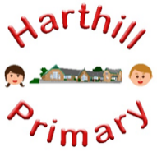

Curriculum Design at Harthill

Our curriculum enables children to:
- Understand concepts, themes and genres
- Acquire and apply knowledge and skill
- Develop vocabulary
So that they:
- develop a strong sense of belonging with a good understanding of the wider world.
- be inspired to raise their ambition.
- grow resilience as determined and independent individuals.
- show kindness, respect and tolerance.
RELIGIOUS EDUCATION AT HARTHILL
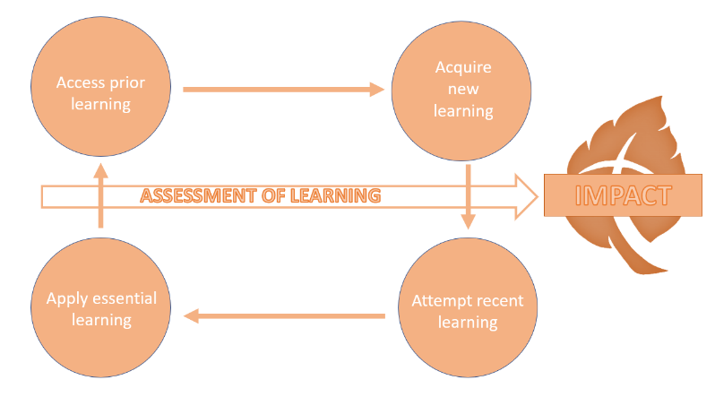
Intent: Through our RE curriculum we explain the value and purpose of RE to ensure all children access, acquire, attempt and apply substantive (factual) and disciplinary (skill-based) knowledge whilst building on their vocabulary, following the Rotherham agreed syllabus. Children will discover, investigate and understand religions and world views. They will face challenging questions about beliefs, communities and human life. Our pupils will learn to explain and express views, thoughts and ideas with respect and tolerance. They will develop an open-minded attitude, asking questions about the ‘why’ of religion by gathering evidence, personal thought time and considering and explaining different views within discussion. Learning will be presented as a creative, thought provoking response which shows understanding, imagination and curiosity.
Our RE curriculum has been designed with our children in mind to ensure it:
- Broadens pupil understanding of the world by linking it to and building on their own experiences.
- Meets the needs of all pupils and supports long term social mobility
- Promotes tolerates through acquired knowledge and opportunities for application
- Promotes diversity as well as British Values with specific focus on religious beliefs and a multi-faith society
- Challenges pupils and promotes resilience
- Addresses the subject specific issues our pupils might face
Implementation:
Through our RE curriculum children will:
-know about and understand a range of religious and world views.
-explore key concepts through new knowledge
-make links and group knowledge to develop schemas
-build vocabulary as a result of direct teaching
- regularly retrieve learning to move knowledge from short term to long term memory
-practice the skills (disciplinary knowledge) to critically engage with an issue.
Impact:
The impact of our RE curriculum is demonstrated in the following ways:
-what children say (pupil questioning, explanations, discussion contributions, verbal retrieval)
-what children do (displays, floor books, drama, mind-mapping for retrieval)

