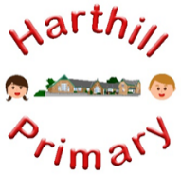

Curriculum Design at Harthill

Our curriculum enables children to:
- Understand concepts, themes and genres
- Acquire and apply knowledge and skill
- Develop vocabulary
So that they:
- develop a strong sense of belonging with a good understanding of the wider world.
- be inspired to raise their ambition.
- grow resilience as determined and independent individuals.
- show kindness, respect and tolerance.
Design and Technology AT HARTHILL
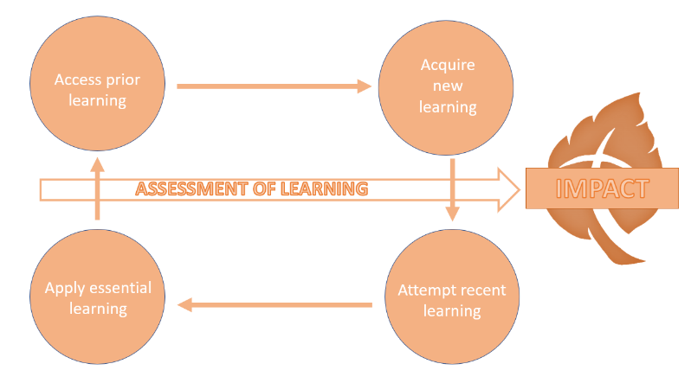
Intent: Through our Design and Technology curriculum children will access, acquire, attempt and apply disciplinary (skill-based) and substantive (factual) knowledge, drawing on a wide range of other curriculum areas such as maths, science, computing and art. Through the evaluation of past and present design and technology, children will develop a critical understanding of its impact on daily life and the wider world. At the start of each unit of work the children will access their prior learning in this area before moving on to acquiring new subject knowledge and skills relevant to the design brief and teaching. Finally, children will evaluate the effectiveness of their own and other’s work.
Our Design and Technology curriculum has been designed with our children in mind to ensure it:
- Broadens pupil understanding and experiences of the world
- Meets the needs of all pupils and supports long term social mobility
- Raises ambition through acquired knowledge and opportunities for application
- Challenges pupils and promotes resilience
- Support children to explore their creativity in different contexts
Implementation:
Through our Design and Technology curriculum children will:
-develop the creative, technical and practical expertise needed to perform everyday tasks confidently and to participate successfully in an increasingly technological world.
-build and apply a repertoire of knowledge, understanding and skills in order to design and make high-quality prototypes and products for a range of users.
- critique, evaluate and test their ideas and products and the work of others
-understand and apply the principles of nutrition and learn how to cook.
Impact:
The impact of our design and technology curriculum is demonstrated in the following ways:
-what children say (pupil questioning, explanations, discussion contributions, verbal retrieval)
-what children do (displays, floor books, structures and mechanisms produced, mind-mapping for retrieval)

